Name: Muhammad Ahsan Ali

Roll No: p176008

Quiz 2 Natural Language processing

Output of Quiz 2 is

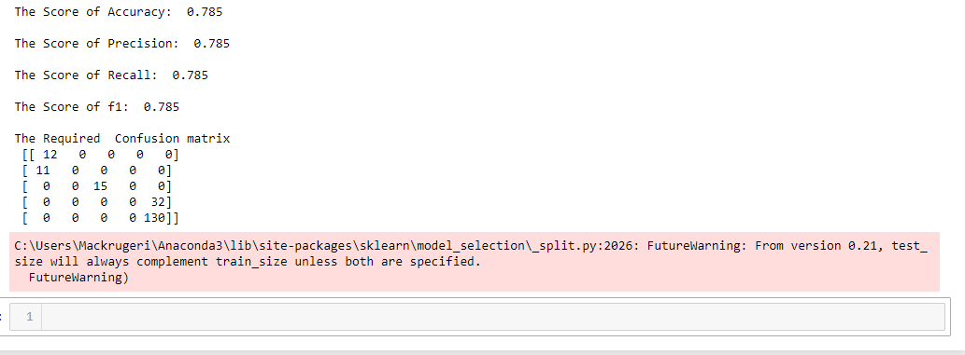

Code

import re

from sklearn.feature_extraction.text import CountVectorizer

from sklearn.feature_extraction.text import TfidfVectorizer

from sklearn.tree import DecisionTreeClassifier

from sklearn.model_selection import train_test_split

from sklearn.metrics import accuracy_score

from sklearn.metrics import precision_score

from sklearn.metrics import confusion_matrix

from sklearn.metrics import recall_score

from sklearn.metrics import f1_score

def accuracy_finding(test_y,labels):

print('The Score of Accuracy: ', accuracy_score(test_y, labels), '\n')

def precision_finding(test_y,labels):

print('The Score of Precision: ',precision_score(test_y, labels, average = 'micro'), '\n')

def recalling_finding(test_y,labels):

print('The Score of Recall: ',recall_score(test_y, labels, average = 'micro'), '\n')

def f1_finding(test_y,labels):

print('The Score of f1: ',f1_score(test_y, labels, average = 'micro'), '\n')

def confusion_finding(test_y,labels):

print('The Required Confusion matrix\n',confusion_matrix(test_y, labels))

label = []

y = []

def complete_processing():

corpus = open('Movies_TV.txt').read()

rows = corpus.split('\n')

rows.remove(rows[0])

rows.remove(rows[-1])

for row in rows:

_, labels, ratings, _ = row.split('\t')

label.append(labels)

y.append(ratings)

vec = CountVectorizer(min_df = 8)

X = vec.fit_transform(label)

vec = TfidfVectorizer(min_df = 8)

matrix_X = vec.fit_transform(label)

dtc = DecisionTreeClassifier(max_depth = 8)

train_x, test_x, train_y, test_y = train_test_split(matrix_X, y, shuffle = True, train_size = 0.8)

dtc.fit(train_x, train_y)

labels = dtc.predict(test_x)

accuracy_finding(test_y,labels)

precision_finding(test_y,labels)

recalling_finding(test_y,labels)

f1_finding(test_y,labels)

confusion_finding(test_y,labels)

complete_processing()

Google Colab Link

<https://colab.research.google.com/drive/1NfrlIL3zk7gS3jeGqJvib8YGsk3A0e8h#scrollTo=R_4JYOFMrCqY>